Laboratory Activity 2 Creating a Website with Images

Objectives:
At the end of this activity, the students are expected to
- Change the font size, color and format of text of a web page
- Describe what is homepage
- Create a home page
- Explain the difference between the two (2) classes of web images
- Differentiate the various types of web images
- Insert a background image
- Insert a horizontal rule image Discussion:
Homepage
A homepage is the main page of the Web site. This is the first page, which the visitors view. On your home page, these are the important things to consider:
 The purpose of the web site
 What is the web site all about?
 How visitors can move from one page to another?
 E-mail link so visitors can email you directly from the initial page.
Font Attributes
To enhance the appearance of our web page and make it more interesting to the visitors, different font size, font style and font face are available in HTML. Table 2 shows the different FONT attributes and their functions:
Table 2. Font Attributes and Their Functions

Attributes Function
COLOR Changes the font color
Uses Color Codes
FACE Changes the font type
If the user doesn’t specify a font the default font is displayed

SIZE Changes the font size
Choices range from 1 to 7, or relative values such as +2

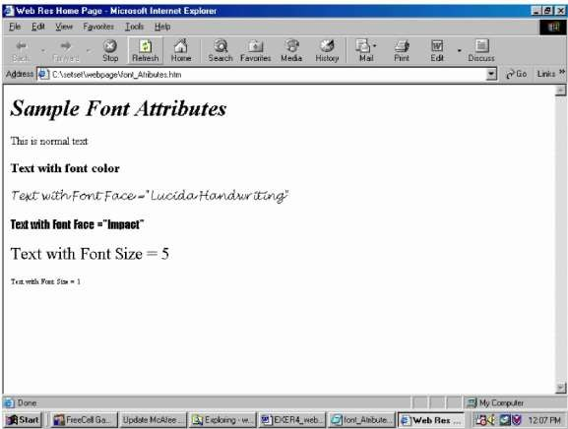
The format use to change the color of the text is <FONT COLOR = " "> with the color number code between the quotation marks. Figure 3.1 shows some of the font attributes.
Figure 1 Web Page with Different Attributes Web Page Images
Images can be used as backgrounds, horizontal rules or as pictures or graphics in any web page. These images make the web page more interesting and colorful. They also help to clarify or make a point being made in the text or as links to other Web pages. They also serve as directional symbols that allow the visitors to navigate through the Web site.
Please take into consideration that the purpose of Web page determines which class of image to use. HTML image tags are <IMG> and </IMG>.
Classes of Images

- Inline Images
 Images that display on the Web page directly, together with the text
- External Images
 Images that are stored separately from the Web page and are displayed only hen the visitor clicks a link to display them
Image Types
- Joint Photographic Experts Groups (.JPEGS) 
Pronounced as JAY-peg
 It has an extension of .jpg, .jpe or .jpeg
 It is a graphic image that is saved using compression techniques to make it smaller for a download on the Web
 When creating a JPEG image, users can specify the image quality to
 reach a balance between image quality and file size
 JPEG files are often used for photographs because they support millions of colors. Photographs are more complex images than any other images
- Graphics Interchange Format (.GIF)
 Pronounced as Jiff or giff
 It has an extension of .GIF
 A graphic file with this type is also saved using compression technique to make it smaller for download on the Web
 GIF however supports more colors and resolutions than JPEG making it more effective for scanned photographs
 LSW compression, the technique that is used to compress GIF files is patented, thus saving in GIF files needs license
 GIF images play one line at a time when loading
 Interlaced GIF images load all at once, starting with a blurry look and becoming sharper as they load
- Portable Network Graphics (.PNG)
 Pronounced as ping
 Designated with a png or ping extensions
 A patent-free alterative to the GIF which has been developed and approved by the World Wide Web Consortium as an Internet graphics standard
 PNG file is also a compressed file that supports multiple colors and resolutions

Table 3. Image Attributes and Their Functions Attributes Function
ALIGN  Controls alignment
 Alignment can be from top, middle, bottom, left, or right
ALT  Alternative text to display when an image is being loaded
BORDER  Defines the border width HEIGHT  Defines the height of the image
 Improves the loading time
HSPACE  Defines the horizontal space that separate the image from the text
SRC  Defines the URL of the image to be loaded YSPACE  Defines the vertical space that separate the image
from text
WIDTH  Defines the width of the image
 Improves loading time
Inserting Background Image
To insert a background image, we will use the BACKGROUND attribute. The BACKGROUND attribute defines the source of the image. This statement tells the browser where to locate the image users want displayed.

Procedure:

Creating an Image File
- Open MS Paint.
- Create an image that will serve as your background for your homepage.
- If you like, you can copy any image file available in Windows and then paste it in Paint.
- Save this file as background.jpg in your project folder
Creating a Home Page
- Open VS Code or Notepad++.

- Enter initial HTML tags. Type <HTML> and then press the Enter key. Type
<HEAD> and then press the Enter key

- Type <TITLE>DLSU </TITLE> and then press the Enter key
- Type </HEAD> and then press the Enter key
- Type <BODY> and then press the Enter key
- Type </BODY> and then press the Enter key
- Type </HTML> and then press the Enter key
- Position the insertion point on the blank line between the <BODY> and
</BODY>
- We know that <H1> tag assigns the largest possible size to a heading and the attribute ALIGN = "CENTER" will center the heading. We will enhance our home page with the <FONT> and </FONT> tags. Click line 6 between the
<BODY> and the </BODY> tags, type <H1 ALIGN = "CENTER"><FONT COLOR = "#000066"> Computer Technician
</FONT></H1> and then press the Enter key.
- With the insertion point in line 7, type <P> In a nutshell, computer technicians perform installation & maintenance or solve problems that people have with their computers. Just as there are different types of computers and different levels of computer systems and networks, there are also several different types of computer specialist. A partial list of some of the job designations in this growing field includes the following:
</P> as the first paragraph of the body.
- Press the ENTER key.
- After the first paragraph, type <H2> What does a computer technician do?
</H2> and then press the Enter key.
- Now, we are to add a bulleted list of information. Recall that in exer1_webpage.htm, we performed this operation without changing the bullet type available, which is the disc. We will now use the bullet type square for this activity. Create a bulleted list for the following elements:

 Desktop Support Specialist
 Network Administrator
 Systems Administrator
 Computer Forensics Specialist
 Help Desk Technician
 Customer Support Analyst
 Internet Professional
- Now, type <H2>Our Services </H2> next and then press the enter key. This would be our next subheading.
- Create another list, using the bullet square, with the following elements:
 Computer Troubleshooting and Repair
 Software Package Installation
 Network Maintenance and Troubleshooting
 Web Page Development and Maintenance
 Printing
We've just created the first part of our web page.
- Now, we are to insert background and horizontal rule image for our web page. To add a background image. First, position the insertion point immediately to the Y in the <BODY> tag and then press the space bar. Type BACKGROUND = "directory and the filename of the image". In this case, use the image file, background.jpg you've created earlier.
- We have just added an image background to our web page. We are now ready to create a horizontal rule image. But we first have to create the horizontal bar. Open your MS Paint and then using the box object, create a rectangular image filled with color blue. Save this at your project folder with filename bluebar.jpg. We will use this as our horizontal rule image.
- Going back to VS Code, point the insertion point to the right of the </H1> and then press the Enter key. Type <CENTER> <IMG SRC = "bluebar.jpg" HEIGHT = 5 WIDTH = 500> </CENTER> as the tag.
This line defines our horizontal rule. It tells that the horizontal rule should be place at center and with height and weight dimensions specified.

- We are to copy this horizontal rule image at the bottom of our 1st bulleted list. Highlight the text <CENTER> <IMG SRC = "bluebar.jpg" HEIGHT = 5 WIDTH = 500> </CENTER> and then click the EDIT menu then Copy. Now, position the insertion point at the end of our _{1st} unordered list and then click the EDIT menu again and then click PASTE. We have now two (2) horizontal rule images.
- Save this exercise as exer2_webpage.htm. View this file on the web browser. Your screen should at least resemble figure 3.2.
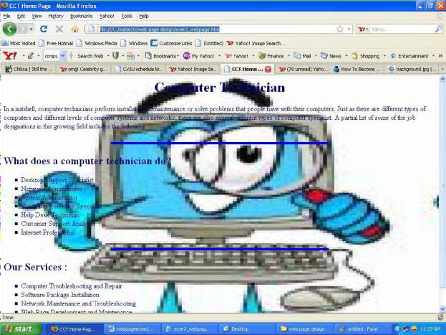

Figure 2. The Finished Work

- Close and exit your Web Browser and Notepad.

- Shut down the computer properly.

Conclusion
Write what you have learned from this activity in two to five sentences only.

